|  |
| --- |
| Description: e-PG Pathshala logo.png  **Information Technology** |
| **Mobile Computing** |
| **Module: Cellular Systems Part 2** |

**Learning Objectives**

* Derivation of distance between co-channel cells and co-channel reuse ratio
* Capacity increase using cluster
* Channel allocation schemes
* Handoffs
* Types of Handoffs

**Introduction**

Cellular Systems or networks are a technology in which a wide geographical area is broken up into small units called cells. The basic motive of cellular technology was to use many low power transistors strategically placed all over the geographical region. Neighboring cells are assigned distinct frequencies or channels which can be reused after a certain distance by the means of clustering thus facilitating frequency reuse. The cells are hexagonal in shape. The size of cells are small in densely populated area and big in sparsely populated area. As per size, cells are labelled as macro, micro, pico cells. Cluster sizes should be chosen such that interference is minimum, channel utilization is maximum/optimum as well as capacity is maximum. Previous module explains basic cellular technology and the principles of frequency reuse and clustering. This module extends the principles by deriving the co-channel distance and ratio. The basic channel allocation schemes would be discussed. The concept of handover would be introduced and types of handovers discussed.

**Clusters**

Each cell is assign a frequency channel or group of channels. Adjacent cells are assigned non - overlapping frequency channels. Group of such cells with non- over lapping frequency is called a cluster. Size of the cluster (number of cells) can be 3, 4, 7, 9, 12, 21(Fig. 3). The size of the cluster C, is according to shift parameters i and j where i is step along one direction and j is step along another direction. To reach from one channel cell to other, I steps are taken in one direction then after 120-degree turn, j steps are taken in other direction as shown in Fig. 1 cells denoted by A are co-channel cells. C is given as

|  |
| --- |
| C = i2 + ij + j2 |

Typical values of C and corresponding shift parameters are given in the table below

**Table 1 i & j for different cluster sizes**

|  |  |
| --- | --- |
| Cluster Size(C) | Values of i and j |
| C=1 | i=1, j=0 |
| C=3 | i=1, j=1 |
| C=4 | i=2, j=0 |
| C=7 | i=2, j=1 |
| C=9 | i=3, j=0 |
| C=12 | i=0, j=2 |

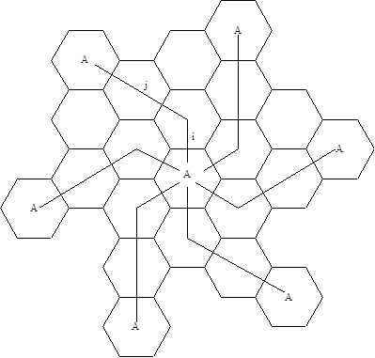

**Figure 1 Shift parameters**

Figure 2Cluster of different sizes

**Figure 3: Clusters of different sizes**

**F1**

**F3**

**F2**

N=3

**F7**

**F8**

**F6**

**F1**

**F9**

**F5**

**F2**

**F4**

**F3**

N = 9

**F4**

**F1**

**F3**

**F2**

N = 4

**F6**

**F5**

**F1**

**F7**

**F4**

**F2**

**F3**

N = 7

**Distance between co-channel cells**

To find distance between co-channel cells, distance between adjacent cells is derived. If R = Radius of cell, Distance between two adjacent cells center is given as per Fig. 4

2 R cos П/6 = 2 R $\frac{\sqrt{3}}{2}= \sqrt{3}$ R

From the geometry of hexagon it can be shown that distance between two co-channel cells is

D = $\sqrt{3}$ R * C; where C is the cluster size and D is co-channel distance as shown in Fig. 5

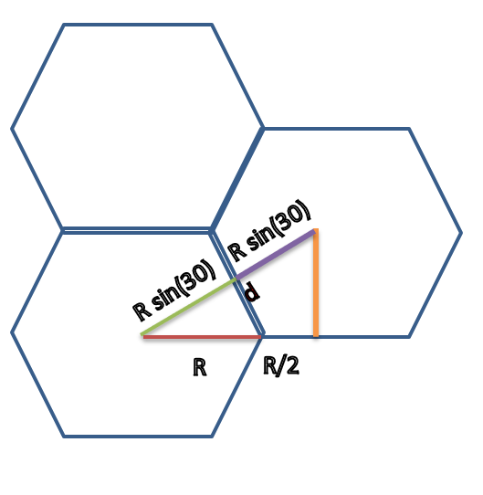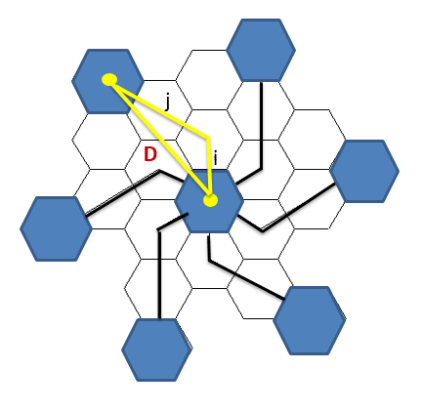

**Figure 4: Distance between adjacent cells** **Figure 5: Co-channel distance**

**Co-channel reuse ratio**

Co-channel reuse ratio defined how cluster size contributes to the increase in capacity. If C is cluster size and D is co-channel distance, co-channel ratio is defined as

q= D/R= (√ 3 *C *R)/R = √ 3C Q= D/R=(√ 3 *C *R)/R = √ 3C

A small value of q provides larger capacity since the cluster size is small whereas a large value of q improves the transmission quality, due to smaller level of co-channel interference. Different values for q for different cluster sizes is given as in Table 2. It can be seen that as cluster sizes increase, q increases.

**Table 2: q values for different cluster sizes**

|  |  |  |
| --- | --- | --- |
| **Step sizes** | **Cluster size C** | **Co-channel reuse ratio (q=D/R)** |
| **i = 1, j= 1** | 3 | 3 |
| **i = 1, j= 2** | 7 | 4.58 |
| **i = 0, j= 3** | 9 | 5.20 |
| **i = 2, j= 2** | 12 | 6 |

**Cluster size and capacity**

**Illustration**A system has S duplex channels;Each cell has K channels; Each cluster has C cells

Therefore S = KC

If the cluster is replicated M times,

Capacity = MKC; Capacity = MS therefore, Capacity α M

**Example**

Area = 1569km2; area /cell = 7km2each;Cluster sizes = 4

Area covered by cluster = 7*4 = 28km2;Number of clusters = 1569/28 = 56

Cluster size = 7; Number of clusters = 1569/49 = 32

We see that as number of cluster increases, capacity increases. More the cluster size, less the number of clusters

**Sectors**

It is seen that clusters increase the capacity while reducing the interference at the same time. Sectoring is basically a technique which can increase the capacity with the same cluster size. In this technique, instead of using one omnidirectional antenna for entire cells, directional antennas are used. (Fig. 6). In effect, a cell is divided into 3 sectors of 120-degree each handled by a directional antenna. The channel set allocated to this cell is also divided amongst the sectors. In Fig. 7 channel set f allocated to a cell is divided into sectors with frequency f1, f2 and f3.

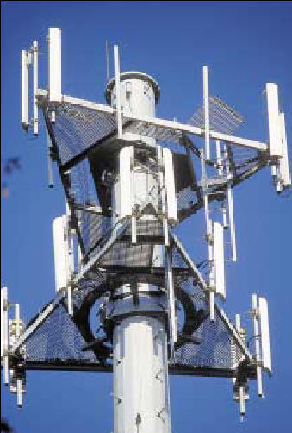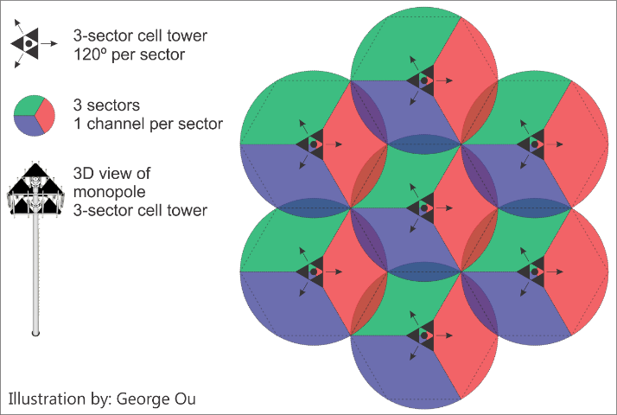

**Figure 6Sectorized Antenna and Sectorization**

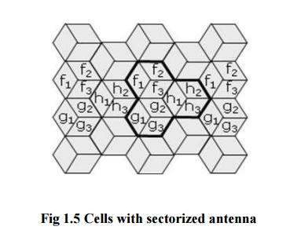

**Figure 7 Frequency channel set divided amongst sectors**

**Limitation of Sectorisation**

Since each sector uses distinct frequency, handoff would be required when user moves from one sector to another. Frequent handovers put an overhead on the network.

**Micro cell Zones**

To overcome handover overhead associated with sectorization , microcells are used. Each cell is divided into three microcell zones. Unlike sectors where different antenna caters each sector, each microcell zone is connected to one base station as shown in Fig. 8. Each micro cell zone uses the same frequency channel which is allocated for the cell. Thus, when a mobile user moves between two microcell zones of the cell,no handover is required.

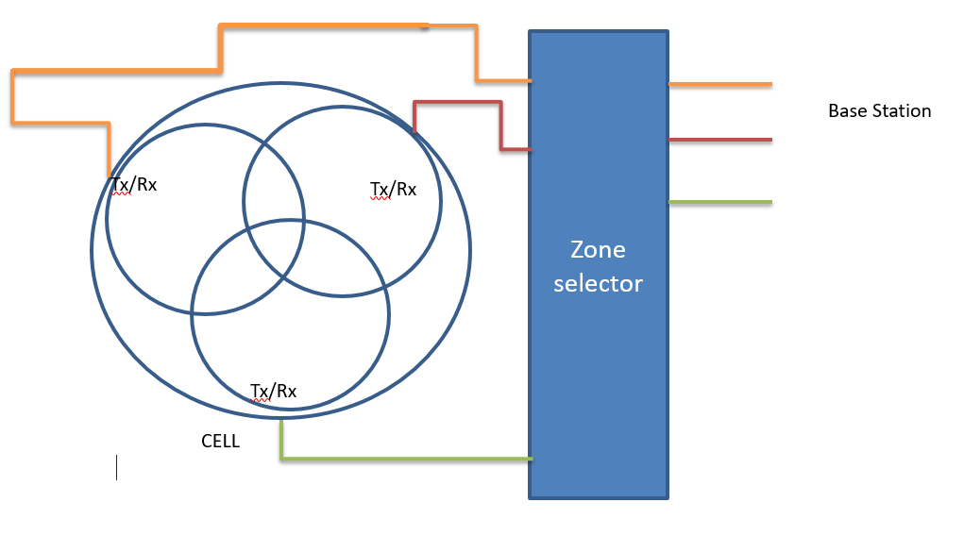

**Figure 8: Microcell zones**

**Channel Allocation schemes**

The different schemes for allocating the channels to a cell is divided into two categories

* Fixed channel allocation
* Dynamic channel allocation

**Fixed channel assignment**

In this scheme, each cell is allocated a fixed number of channels. The devices within that cell communicates only through the channels allocated to it. If there are no free channels available, communication cannot take place. This scheme is simple to implement but is the worst channel utilization because the user keeps the channel for the whole time whether it is using or not.

**Borrowed channel allocation schemes**

In this scheme, if all the allocated channels of a cell are exhausted, a channel from neighboring cell is borrowed. A cell that borrows free channels from its neighbor is called **acceptor cell**. A cell which donates its free channel to acceptor cell is known as **donor cell**. In this process, it is ensured that none of the calls in progress are interrupted. The borrowing processing can be according to one of the following schemes

* Borrow from the richest: Borrowing is done from an adjacent cell which has largest number of free channels
* Borrow first available scheme: Select the first free channel found for borrowing using a search algorithm
* Basic algorithm with reassignment: Return the borrowed channel when channel becomes free in the cell

**Dynamic Channel assignment**

In this scheme, a central pool of the channels is managed. New calls are assigned the channels as they arrive in the system. After each call is completed, the channel is returned to the central pool. Two cells can be assigned same channel if the distance between them is sufficient to reduce co-channel interference.DCA schemes can be centralized or distributed

* Centralized DCA scheme involves a single controller selecting a channel for each cell
* Distributed DCA scheme involves a number of controllers scattered across the network

**Hybrid allocation scheme**

This scheme is combination of both FCA and DCA techniques. The total number of channels available for service is divided into fixed and dynamic sets. The fixed set contains channels that are assigned to predefined cells as in the FCA schemes. The dynamic set is used by all the users. When a call requires a channel in a cell but there is no free channel available, a channel from the dynamic set is assigned to the call.

Handover/Handoff

When the user moves from one cell to another , while a call is in progress the channel from new cell is assgned to ensure that there is no call drop. The process of handing over the call from old base station to new base station is known as handover/handoff. In some countries like Europe, cellular handover is used and in some countries like North America, cellular handoff is used(Fig ). For handover decision, the signal strength of the current base station, is compared with the signal strengths of the surrounding stations. Both mobile station and base station perform quality measurement on current link as well as in the neighboring cells.If difference of quality measurement is greater than a thrashold known as HO_MARGIN and the channels are available with the new cell, handover is initiated (Fig. 9).

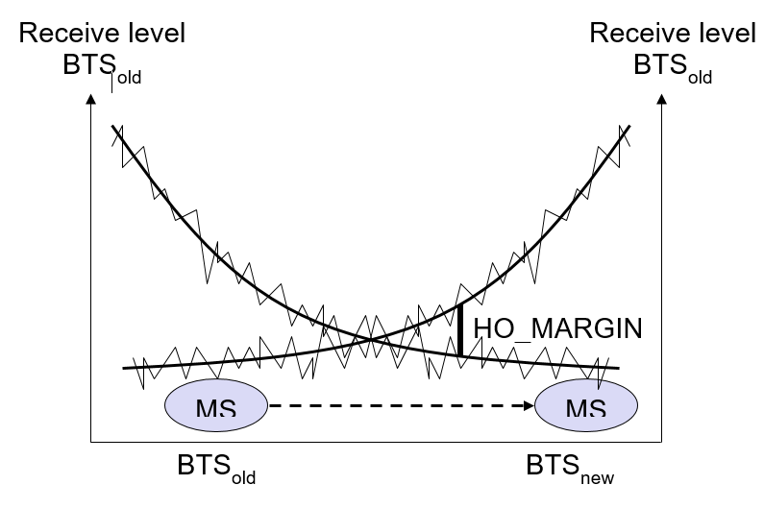

**Figure 9: Handover margin**

**Types of Handover**

Handovers can be performed in two waves

**Hard Handover (Break-Before-Make)**

Existing radio link from the current base station must be dropped for some period of time before connecting to new base station. No voice or data transmission takes place during the break period. Break is too short (60 ms) to observe the interruption. GSM uses hard handovers

**Soft Handover(Make Before You Break)**

No breakup with the previous link is done until new link with the new Base station is established. Thus handover is seamless. Hence it is possible to have connection/acquisition with more than one cell/channel at same time. Used in CDMA.

**Types of handoffs in different generations**

The handover controlling entities were different in different generations of telecommunications**.**Fig. summarizes the different types of controlling entities in 1G,2G and 3G communications**.**